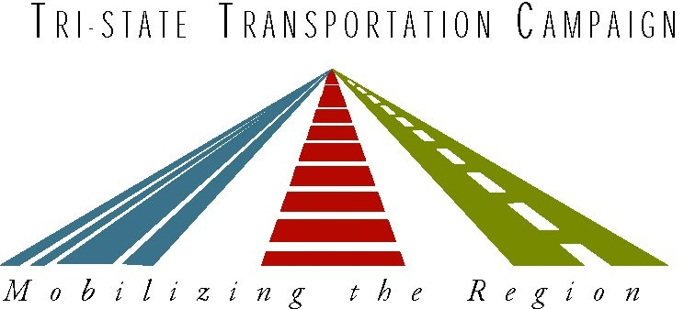

NYS Complete Streets
Local Initiatives
2/13/2013

NB: This is not a comprehensive list; it will be updated as we learn more.

Complete Streets Resolutions and Policies Passed—Cities, Towns and Villages
Angelica
Babylon*
Bethlehem*
Binghamton
Brookhaven*
Buffalo
Canandaigua
Chester
Clyde
Cuba
Dobbs Ferry*
East Hampton
Elizabethtown*
Fort Edward, Town and Village
Glens Falls*
Great Neck Plaza
Gowanda
Hinsdale
Village of Hudson Falls
Independence
Ilion
Islip*
Johnsburg
Kingsbury
Kingston*
Village of Lake George
Lake Luzerne
Lewis
Lewisboro*
Malone
New York City, Street Design Manual & Sustainable Streets
Strategic Plan
Newcomb
New Rochelle
North Hempstead*
Rochester
Salamanca
Saratoga Springs*
South Hampton
Warrensburg
Westport
Williamson
Wilmington

Complete Streets Resolutions and Policies Passed—Counties
Allegany County
Cattaraugus County
Erie County
Essex County*
Suffolk County*
Ulster County

Complete Streets Resolutions and Policies—in Process
Albany
Alfred
Angelica
Dewitt
Ellicottville
Village of Solvay
Portville
Somers
Syracuse
Troy
Wellsville

Organizations spearheading a collaborative local approach:
Shared Access, Saratoga*
Southern Tier Wellness Partnership
Southern Westchester Energy Action Consortium*
Essex County Public Health & Rural Action Now!*
St. Lawrence Health Initiative
Glens Falls Hospital *
Cornell Cooperative Extension, Allegany & Cattaraugus Counties
Cornell Cooperative Extension, Ulster County*
“Healthi Kids” Finger Lakes Health Systems Agency
Onondaga County Health Department

*Marks entities that Tri-State Transportation Campaign has worked with

