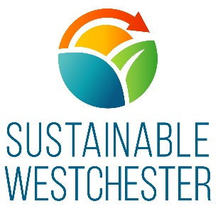
CLEAN ENERGY INTERNSHIP
Westchester Power Community Choice Aggregation ………………………………………………………………………….
Dept: Westchester Power
Hours: Flexible. 15-18 hours a week for full time students. Eligible interns not taking classes can work up to 40 hours per week.
Location(s): Mount Kisco, NY and remote via zoom, etc
The Organization
Sustainable Westchester is a nonprofit membership organization of Westchester County local Governments that facilitates effective collaboration on sustainability issues. The organization brings socially responsible, environmentally sound, and economically viable solutions that create healthy, resilient and sustainable communities.

The Clean Energy Internship
The Clean Energy Internship This position reports to the Westchester Power Program Manager and will assist with the research of energy-related environmental justice issues in Westchester County, NY and the subsequent development of an Energy Justice Strategy to address such issues. The Westchester Power program aids municipalities and their residents in the transition to clean energy and hopes to provide these benefits to the most disadvantaged groups.
Successful candidates will be excellent communicators, will have a strong interest in environmental justice/energy, and will work with our team to achieve the following Program Goals:
- Environmental Justice Research: Assist in research of energy-related environmental justice issues in Westchester County, including, but not limited to energy burden, air pollution, siting of hazardous facilities, identification of frontline communities, etc.
- Data Mapping & Analysis: Must be highly organized and able to track and analyze data and information. GIS experience preferred.
- Energy Justice Plan Development: Assist in the development of a strategic plan for Sustainable Westchester and Westchester Power to address environmental justice concerns in Westchester County
- Presentation Skills: Be able to draft presentations and communicate our findings to diverse audiences; possibly presenting such findings at community events/online webinars

Eligibility: Students will be required to meet one of the following eligibility requirements:
- A student attending or having attended a college or university located in New York State within the last calendar year;
- A New York State resident attending or having attended a college or university outside of New York State within the last calendar year;
- A 16- to 24-year-old participating in a work preparedness training program such as Board of Cooperative Educational Service (BOCES), technical high schools, AmeriCorps NCC, the Excelsior Conservation AmeriCorps, etc.; or
- A military veteran.
- To Apply: Please forward your resume and optional cover letter by email to human resources at HR@SustainableWestchester.org

- Learn more about NYSERDA’s Clean Energy Internship here
Location(s): Our office is located at 40 Green Street, Mt. Kisco, NY 10549 and is within walking distance from the Mount Kisco Train Station, located on the Harlem Line of Metro North. For the time being, most work will take place remotely.

