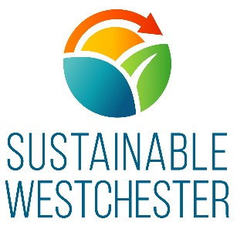
CLEAN ENERGY INTERNSHIP
MARKETING & COMMUNICATIONS INTERN
Hours: Flexible. 15-18 hours a week for full time students. Eligible interns not taking classes can work up to 40 hours per week. PT or FT interns may participate in this program up to a total of 960 hours.
Location(s): Mount Kisco, NY and currently remote via zoom, etc
The Organization
Sustainable Westchester is a nonprofit membership organization of Westchester County local Governments that facilitates effective collaboration on sustainability issues. The organization brings socially responsible, environmentally sound, and economically viable solutions that create healthy, resilient and sustainable communities.

The Clean Energy Internship in Marketing & Communications
This position reports to the Director of Marketing, Communications and Outreach and will assist with development of various renewable energy projects to advance knowledge of clean energy initiatives.
Successful candidates will be excellent communicators, with a strong interest in environmental issues and will work with our team to achieve the following Program Goals.
- Assist with monitoring active programs and developing strategic and tactical ways to improve them
- Submit ideas for marketing programs designed to enhance and grow the organization’s umbrella brand and specific programs
- Report directly to the Director of Marketing in collaboration with the product team to create strategies, campaigns and deliverables
- Collaborate with member municipalities’ key environmental and sustainability committees as a brand ambassador to ideate and bring campaigns and programs to execution
- Act as a resource to assist with completion of large projects.

Skillset required
- Knowledge of marketing strategies, including continuing education of new marketing tactics and tools
- Strong written and verbal communication
- Ability to translate research into common language
- Proficiency with (Microsoft) work processing, spreadsheet and presentation software
- Knowledge of graphic design programs a plus
- Aptitude with various social media platforms as well as the metric tracking tools
- Ability to learn and process information quickly
- Exceptional organization, project and time management skills
- Ability to work remotely

- Eligibility: Students will be required to meet one of the following eligibility requirements
- A student attending or having attended a college or university located in New York State within the last calendar year;
- A New York State resident attending or having attended a college or university outside of New York State within the last calendar year;
- A 16- to 24-year-old participating in a work preparedness training program such as Board of Cooperative Educational Service (BOCES), technical high schools, AmeriCorps NCC, the Excelsior Conservation AmeriCorps, etc.; or
- A military veteran.
To Apply: Please forward your resume and cover letter to HR@SustainableWestchester.org
Learn more about NYSERDA’s Clean Energy Internship program here

