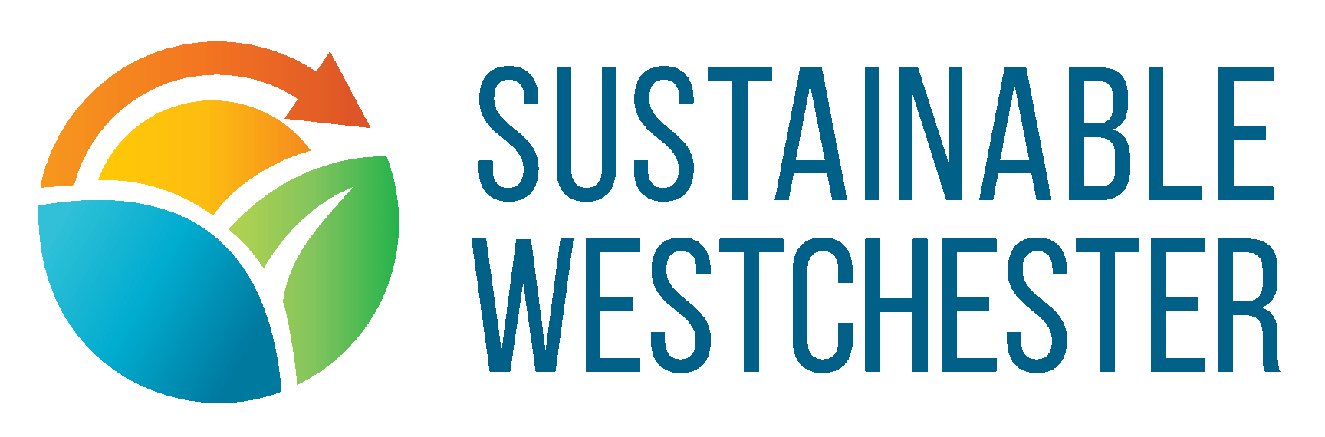
Job Description: Outreach Coordinator
Organizes and executes municipal and community outreach activity in support of Sustainable Westchester’s Westchester Power program and associated energy initiatives such as Community Solar and the EnergySmart Homes program.
The Outreach Coordinator should be well versed in the language of these program areas in order to deliver content specific to each. The Outreach Coordinator is expected to regularly attend and/or present at meetings and events in the evening and on weekends.
Essential Duties and Responsibilities
- Proactively schedule, coordinate and provide direct community outreach, participating in and organizing community events, municipal and civic group meetings and other activities (currently virtual, but expected to be on site at some point).
- Present program updates to elected officials and key community stakeholders in all municipalities, responding to questions and concerns where appropriate.
- Foster and maintain relationships with the elected officials and key community stakeholders in all participating municipalities, regularly updating progress and responding to questions and concerns.
- Deliver, distribute, and periodically update program materials.
- Under the supervision of the Marketing Director, make social media postings pre and post events where appropriate.
- Identify, build and maintain grassroots relationships with municipal officials, civic groups, volunteers, etc.
- Record all outreach interactions in the Customer Relationship Management system to facilitate compliance reporting and program development.
- Support outreach planning by maintaining necessary information such as the calendar of municipal meetings and community events.
- Assist the Marketing Director with the development of the Outreach Plan including annual / seasonal / contractual events and inclusive of all member municipalities.
Additional Responsibilities:
- Provide phone support for Westchester Power or other program customers when volumes require and to get first-hand feedback as part of the Outreach Coordinator’s training.
- Master and adhere to company data security policies and procedures.
- Participate in corporate “Green Business Partnership” (sustainable operations practices) activity.
- Take advantage of training and learning opportunities provided by the company.
Qualification Requirements:
- The position is based in Westchester County, and when COVID/public health considerations permit in the future, requires regular travel to offsite meetings and events across the County. The candidate must have a valid driver’s license and reliable fully insured automobile.
- The position requires occasional weekend and frequent evening attendance at community events.
- All candidates must demonstrate a commitment to the mission, values, and philosophy of Sustainable Westchester.
- All candidates must demonstrate aptitude for problem-solving; ability to determine solutions for customers (consultative approach) and must possess excellent verbal and written communication skills.
- All candidates must demonstrate must be results-oriented and able to work both independently and within a team environment.
- A post-secondary degree. Additional related experience is a plus.
- Facility with standard office software; flyer/presentation/marketing material design skills desirable.
Local travel required for this position.
Job Type: Full-time
Required travel: 25% (Required)
Benefits: Paid time off; Health insurance
Schedule:
- Monday to Friday, 9am – 5pm
- Evening and weekend meetings required
Spanish language proficiency a plus
To apply: please send cover letter and resume to HR@sustainablewestchester.org
Sustainable Westchester is an environmental non-profit organization dedicated to improving the quality of life in Westchester County by promoting programs that benefit our local communities - energy conservation, reduction of greenhouse gases, food scrap composting, waste reduction, community solar, electric vehicles and more.

