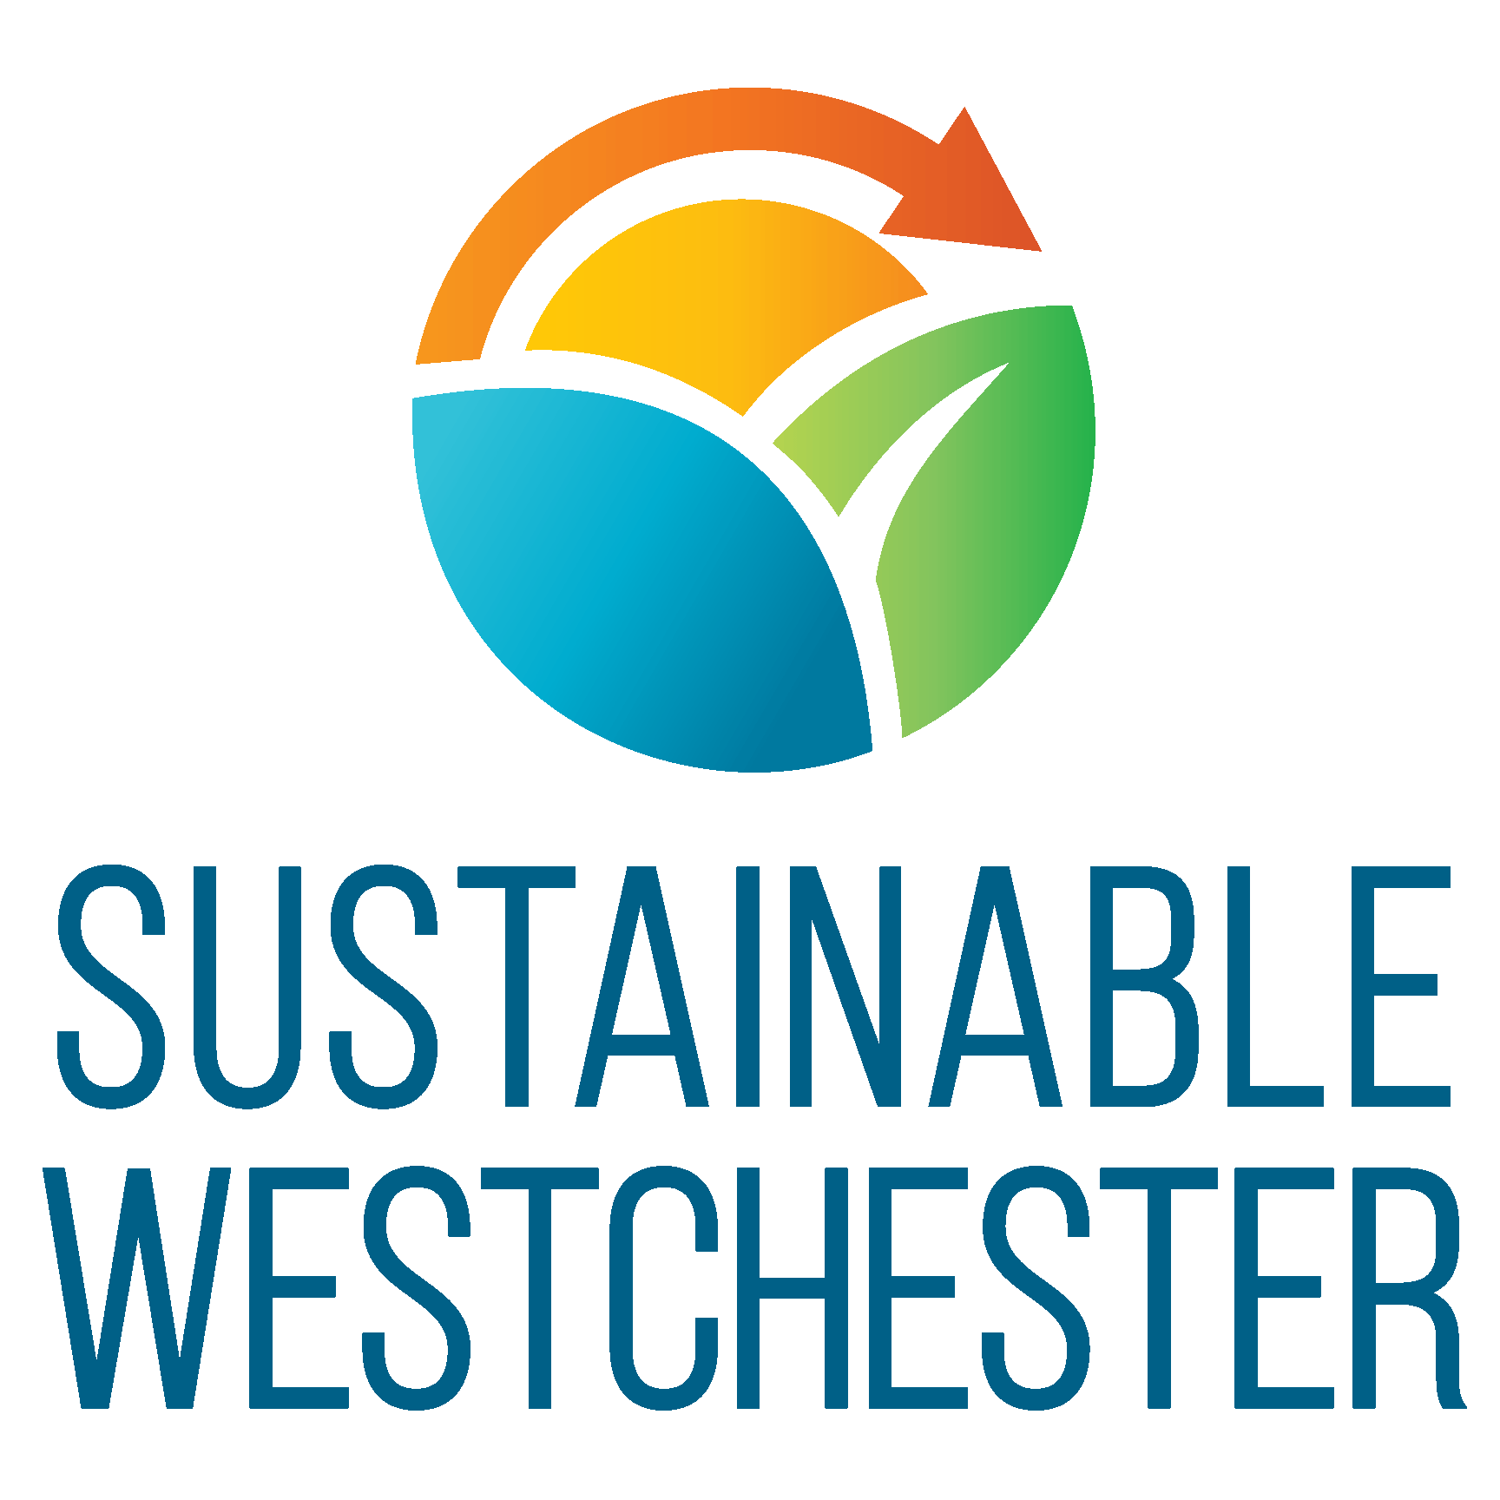

SUSTAINABLE WESTCHESTER
WESTCHESTER POWER
CCA PROGRAM

REQUEST FOR PROPOSALS

Accounts Served by
Con Edison in the Yonkers Service Territory

August 6, 2021

Proposals must be received on or before August 16, 2021 at 12PM and must be submitted by email to dan@sustainablewestchester.org & te.pricing@transparentedge.com

Table of Contents
Purpose 3
Prequalified Bidders 3
RFP Submission and Bidding Process Overview 3
Background 4
Eligible Customer Classes 5
Participating Municipalities 5
Aggregated Data 7
Acknowledgement of Key Elements of the Electric Service Agreement 7
Compliant Bid Criteria 10
1. Price-Not-To-Exceed 10
2. Products 10
3. Terms 11
4. Tranches of Quotes: 11
RFP Submission and Auction Participation 12
RFP Submission: 12
Auction Platform Registration: 12
Final Bid Submission – Live Auction/s: 12
Correspondence: 13
Requests for Clarification 13
Respondent Comments on ESA 14
Proposal Evaluation 14
Evaluation Weighing 15
Reservation of Rights 15
Confidentiality and the New York State Freedom of Information Law 16
Acknowledgement / Signature 17
Attachment 17

Purpose
Sustainable Westchester, Inc. (“SW”) seeks, via this Request for Proposals (“RFP”) an Energy Services Company or Companies (“ESCO”) licensed to supply electricity in New York State to supply electric power to the City of Yonkers (“Yonkers”) as part of the Westchester Power Community Choice Aggregation (“CCA”) Program (“CCA Program”).

The selected ESCO/s will sign an Electric Service Agreement (“ESA”) with Yonkers and SW to supply electricity for the Yonkers CCA Program that will begin with meter read dates in November 2021 in accordance with terms and specifications described in this RFP and its attachments. This ESA will be substantially in the form of the 2021 Yonkers ESA Template as posted on the RFP webpage at:
https://sustainablewestchester.org/wp/bids-2021-yonkers-rfp/.

Prequalified Bidders
Sustainable Westchester recently concluded a Request For Information solicitation and notified qualified bidders. Only qualified bidders are eligible to submit a proposal and bid on this RFP.

RFP Submission and Bidding Process Overview
Prequalified bidders should review this RFP document and -
- Initial the “Acknowledgement of Key Elements of the Electric Service Agreement”
- Sign and return this document to the contacts indicated, together with the indicative pricing requested.
- Coordinate with Transparent Energy for details of participating in the final bid submission via live auction process.

Background
CCAs in New York State are enabled and governed by the Order Authorizing Framework for Community Choice Aggregation Opt-Out Program (Case 14-M-0224, Proceeding on Motion of the Commission to Enable Community Choice Aggregation) (“CCA Framework Order”) issued by the Public Service Commission (“PSC”) on April 21, 2016. The CCA Framework Order is provided for download on the RFP web page. ESCOs that submit a response to this RFP (“Respondents”) must comply with the CCA Framework Order and subsequent clarifying orders as well as all requirements of this RFP and its attachments.

The Westchester Power Program is the first CCA in New York State, having been authorized initially as a pilot under the PSC’s Order Granting Petition in Part (Case 14-M-0564, Petition of Sustainable Westchester for Expedited Approval for the Implementation of a Pilot Community Choice Aggregation Program within the County of Westchester), issued February 26, 2015.

SW is a 501(c)(3) non-profit organization with 45 member municipalities (44 Villages, Towns and Cities, as well as Westchester County). SW serves as the administrator for the CCA Program (“CCA Program Administrator”), organizing the procurement, overseeing ESCO performance under the ESAs, organizing educational outreach activities and, in conjunction with the ESCO, providing customer service. Under the CCA Framework Order, SW is further tasked, as CCA Program Administrator, with working with ESCOs, municipalities and other parties to promote other elements of the NY State “Reforming the Energy Vision” (“REV”) energy plan.

The CCA Program has been in operation since 2016 when it launched with 20 municipalities, 17 in the Consolidated Edison service territory, and 4 in NYSEG territory (Bedford is in both). Currently, there are 28 participating municipalities, 24 in Con Edison service territory and 5 in NYSEG territory; this number will rise to 29 with the addition of Yonkers, which lies in the Con Edison service territory.

Eligible Customer Classes
Under the CCA Framework Order, all customers in the Residential and Small Commercial rate classes are eligible for opt-out treatment in CCAs.

The current enrollments in the 2021 Yonkers ESA include the following rate classes:

Residential classes  - SC 1 – Residential and religious  - SC 8 Multiple Dwellings -Redistribution  - SC 12 Multiple Dwelling - Space Heating  - SC 13 Bulk Power - Housing Developments | Small commercial class  - SC 2 – General - small

Participating Municipalities
Yonkers has passed enabling legislation, been approved for participation by the PSC, and has executed a binding Memorandum of Understanding (“2021 Yonkers MOU”) that commits Yonkers to participate in the Yonkers CCA Program beginning in October 2021 that will be serviced by the qualifying ESCO selected by SW through this RFP process (the “Selected ESCO”).
Yonkers’ executed MOU is included as Attachment 1.

Aggregated Data
The CCA Framework Order provides that SW may share with Respondents certain aggregated utility data (“Aggregated Data”) for Yonkers as a Participating Municipality. This includes the number of eligible customers by service class, the aggregated peak demand (kW) (for electricity) by month for the past 12 months by service class to the extent possible, and the aggregated energy (kWh) for electricity by month for the past 12 months by service class. This Aggregated Data shall not include any data for any service class that contains so few customers, or in which one customer makes up such a large portion of the load, that the aggregated information could provide significant information about an individual customer’s usage.

The Aggregated Data has been provided to bidders during the Request For Information (RFI) qualifying phase after receipt of an executed copy of the Data Confidentiality Agreement. This authorization to use the Aggregated Data expires on September30, 2021.

Acknowledgement of Key Elements of the Electric Service Agreement
- Upon completion of the RFP, the Selected ESCO/s will be expected to enter into an ESA substantially in the form of the 2021 Yonkers ESA with Yonkers and SW. The 2021 Yonkers ESA grants the Selected ESCO/s the exclusive right to be the default provider of Firm Full-Requirements Power Supply to participating residents and small businesses in Yonkers. The Respondent must provide 100% of the electricity supply requirements for these accounts.
- The Selected ESCO/s must coordinate with Yonkers’ designated staff, Sustainable Westchester and its partners in order to deliver services required under the ESA.
- The Selected ESCO/s warrants that it has internal monitoring procedures and processes to ensure faithful performance of the 2021 Yonkers ESA and compliance.
- Con Edison remains responsible to deliver power through its transmission and distribution systems and for maintaining system reliability. Selected ESCO/s shall notify Participating Consumers that if they have service reliability problems, they should contact the appropriate utility for repairs.
- The Selected ESCO/s will arrange for a single consolidated utility bill to be sent to Participating Consumers by the appropriate utility.
- Collection and credit procedures are to be the responsibility of Con Edison and the individual Participating Consumer. Participating Consumers will be required to remit and comply with the payment terms of Con Edison. Sustainable Westchester and Yonkers will not be responsible for late or no payment on the part of any of its Participating Consumers and will have no separate credit or deposit policy.
- The Selected ESCO/s will assist Sustainable Westchester to develop performance reports to the New York State Public Service Commission providing tracking information related to price, service, quality and other factors deemed important. Reporting requirements are specified in the ESA.
- The Selected ESCO/s must provide customer service for Participating Consumers comparable to that provided by utility customer representatives, including those requiring non-English verbal and written assistance. The Selected ESCO must provide customer service for hearing impaired Participating Consumers.
- Sustainable Westchester will maintain a website with account management functionality (i.e., on boarding of opt-in, opt out, and “opt up” migration to 100% Renewable Clean Power Product). Sustainable Westchester will then report this activity to the Selected ESCO, who must maintain a database to track account enrollment and billing data. The website will also provide basic information concerning the CCA Program and will facilitate customer inquiries by providing a platform for the submission of questions by email or text.
- Sustainable Westchester and Yonkers retain the right to control the content of the Opt-Out Notices. The Opt-Out Notices will be mailed at the expense of the Selected ESCO.
- The Selected ESCO/s will coordinate with Sustainable Westchester to establish the mailing list for the opt out notification letters. In order to allow time for the 30 day opt-out and mandated rescission period, the notification letters for the 2021 Yonkers ESA should be mailed out in September 2021.
- The utility will charge a fee for the provision of aggregated consumption data and also for detailed customer data. The rates are set out in the December 14, 2017 Order Establishing Community Choice Data Access Fees as $0.16 and $0.64 respectively. In 2.1 of the ESA, those fees are identified as the responsibility of the Selected ESCO. The utility data fees should therefore only apply to the quarterly mailing lists supplied by Con Edison for Newly Eligible Customers.
- Competitive Supplier shall pay Sustainable Westchester a program management fee per kWh paid for, and a fee for each kWh delivered to the auction service company, Transparent Energy, both to be set out in the ESA.
- Competitive Supplier shall, at its expense, print and mail one letter or postcard per year to all active Participating Consumers, the design of which shall be determined by Yonkers or Sustainable Westchester.
- Sustainable Westchester requires certain data to be provided to Sustainable Westchester by the Selected ESCO on a regular schedule for the purposes of stakeholder reporting and customer service. The requirements are detailed in Exhibit D of the ESA.

Respondent acknowledges the aforementioned elements of the Electric Service Agreement:

____________
Initials

Compliant Bid Criteria
Respondents must submit a compliant bid that meets the below criteria (“Compliant Bid Criteria”):

1. Price-Not-To-Exceed
The price for Firm Full-Requirements Power Supply, as defined in the ESA, must meet the requirements specified in the MOU in Attachment 1, be inclusive of fees owed to Program Manager and all other fees related to Standard Product and 100% Renewable Clean Power Product as outlined below, and be less than:

- Residential accounts: 8.70 cents/kwh
- Small commercial accounts: 8.60 cents/kwh

2. Products
Respondents must provide an indicative supply quote for each of the two following electricity products in their RFP Submission:

- Standard Product that meets all New York State requirements including the Renewable Portfolio Standard.

- 100% Renewable Clean Power Product comprised of the Standard Product plus New York Voluntary Clean Power RECs as set out in Exhibit A - Part 2 of the 2021 Yonkers ESA. The Clean Power RECs shall be derived from hydropower, solar energy or wind energy generation, as defined in, and subject to, the environmental attribute and delivery rules of the Public Service Commission’s Environmental Disclosure Program. Respondent shall purchase Voluntary Clean Power RECs in an amount equal to 100% of the Participating Consumers’ electricity usage less any then-current Tier 1 REC purchase obligation applicable to alternative retail electric suppliers in New York.

3. Terms
Respondents must provide supply quotes for the Products outlined above for at least three (3) of the following terms:
- 12 Month term
- 18 Month term
- 24 Month term
- 36 Month term
- 48 Month term

4. Tranches of Quotes:
A unique set of bids consist of prices for the both products & at least three (3) of the terms. The data provided has been divided into multiple tranches. Respondents must provide indicative supply quotes for each scenario below:
- Scenario 1: Aggregation of all accounts
o 1a: Aggregation of all accounts across all rate classes
▪ 1 unique set of bids
o 1b: Aggregation of all residential rate class accounts
▪ 1 unique set of bids
o 1c: Aggregation of all commercial rate class accounts
▪ 1 unique set of bids

RFP Submission and Auction Participation

RFP Submission:
Respondents must deliver their response to this RFP, inclusive of indicative supply quotes, to the contacts indicated below via email by 12PM, EST, August 16th, 2021. Please provide the name and contact information (phone, fax, email, cell phone number) for the sales representative that will accept and process the ESA. If different from the above, please also provide the name and contact information (phone, fax, email, cell phone number) for the sales representative that will manage the ESA.

Auction Platform Registration:
Respondents must coordinate with the Transparent Energy team to submit final bids through Transparent Energy’s proprietary reverse auction platform. Respondents are encouraged to have any existing Transparent Energy representative submit bids during the live auction; however, Transparent Energy will provide additional training for other employees as needed.

Final Bid Submission – Live Auction/s:
The Live Auction to solicit final & executable bids will be scheduled for the week of August 16th, time & date to be announced, and subject to change based upon review of RFP submissions.
SW may conduct up to three (3) live auctions based on the Tranches of Quotes detailed above. Each auction will last for an initial fifteen (15) minutes.
Respondents will be provided with necessary details & instructions on bidding & auction set-up at least twenty-four (24) hours prior to Live Auction.

Correspondence:
Email submissions, and any questions and correspondence should be made to the following contacts at Sustainable Westchester:

Dan Welsh
Westchester Power Program Director
dan@sustainablewestchesterpower.org
(914) 242-4725 x 101

Nina Orville
Executive Director, Sustainable Westchester
nina@sustainablewestchester.org
(914) 242-4725

Luke Nemes
Transparent Energy, Director of Procurement
Te.pricing@transparentedge.com
(862) 210-8770

Requests for Clarification
Respondents are required to submit any question about the RFP to the email addresses indicated above. The deadline for receipt of questions is 2:00pm EST on July 5th, 2021. Respondents are requested to keep all questions concise. SW will email all questions and answers to all other Respondents.

Respondent Comments on ESA
If Respondent is hesitant to agree to any of the Key Elements or any other clause of the ESA, please submit a detailed reason why.

Proposal Evaluation
- It is the intent of Sustainable Westchester to select a single ESCO or multiple ESCOs to serve Yonkers through the CCA Program.
- This is a non-binding RFP.
- The award decision will be made on the basis of best value.
- SW reserves the right to ask for a “Best & Final” bid prior to execution.
- Respondents’ proposals, when submitted, become the property of SW. SW does not guarantee any award, whether partial or full, to any Respondent.
- SW reserves the right to disqualify from consideration any Respondent who does not comply with the conditions of this RFP.

Respondents’ proposals will be evaluated for the best value to Yonkers based upon the following criteria. The weight of each criterion in the final selection decision is indicated by the percentage value assigned to it.

Evaluation Weighing
The price offered by the Respondent for the 100% Renewable Clean Power Product | 85%
The price offered by the Respondent for the Standard Product | 5%
The Respondent’s qualifications as informed through the RFI process, industry reputation and contribution to a competitive market | 5%
The Respondent’s willingness to sign the ESA substantially in the form presented and/or adherence to key elements | 5%

Reservation of Rights
- This RFP is not an offer to purchase power supply and associated services.
- SW reserves the right to accept or reject any and all responses and also reserves the right to cancel or reissue this RFP at any time throughout the process.
- SW is not responsible for any costs incurred by other parties in the preparation of responses to this RFP.
- SW reserves the right to waive any RFP requirements that are not material.

Confidentiality and the New York State Freedom of Information Law
SW will treat all information provided by Respondents as public information following the conclusion of the selection process unless Respondent requests information to be treated as confidential at the time of bid submission. Any request for confidential treatment of information must be included in the cover letter of Respondent’s response and must explain why disclosure of the information is not in the best interest of the public and must the identify specific basis under the New York State Freedom on Information Law (Public Officers Law, Article 6, Sections 84-90) for the exemption from disclosure of such information. The cover letter must also contain the name, address and telephone number of the individual authorized to respond to SW about the confidential nature of the information. If the Respondent designates any information in its proposal as confidential, the Respondent must also submit one (1) copy of the response from which confidential information has been redacted. The confidential material must be redacted in such a way as to allow the public to determine the general nature of the material removed and to retain as much of the response as possible.

Acknowledgement / Signature

_______________________________
Signature

_______________________________
Name of Signatory

_______________________________
Name of Company

Attachment
Attachment 1 - Signed Memorandum of Understanding from Yonkers

