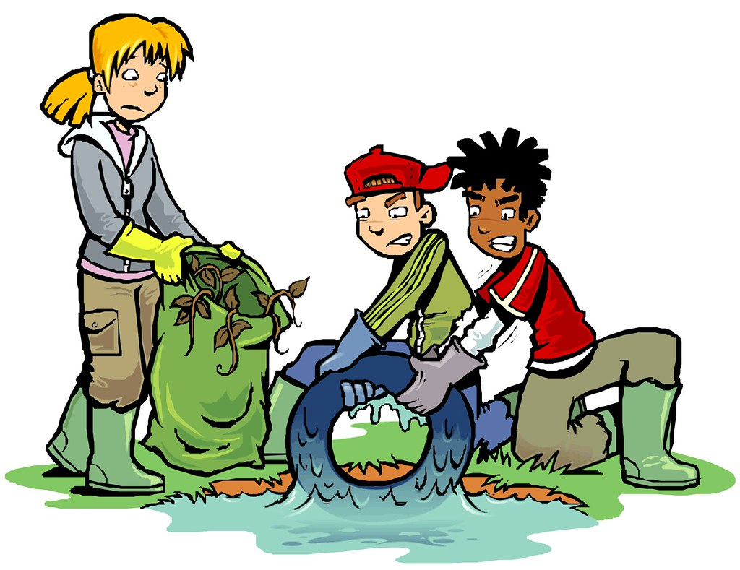

VILLAGE-WIDE CLEAN-UP WEEKEND

Hastings is a Neat Place to Live

Hastings will celebrate its annual Clean-up weekend,
April 27th and 28th
Residents of Hastings take pride in the village’s appearance,

Let’s roll up our sleeves and get our hands dirty!
And make a difference in our community.

Here is what you can do to make Clean-up Day 2024.
an outstanding success.
Select any site to clean and indicate the area you selected!

Online Registration
www.hastingsrecreation.org

Trash bags are available at the
Community Center all week
Saturday morning, starting at 9:00 AM
Lisa will also hand out bags at the VFW.

