Attachment B: Individual Installer Application Form
Note: If multiple Installers are applying as part of this proposal, this attachment must be completed by each Installer individually.

Cover Letter
Installer Name: ________________________________________________________________________
- The Company is licensed and authorized to do business in New York State. The Company is fully insured to perform the work under the RFP.
- The Company is duly organized and in good standing under the laws of the jurisdiction in which it is organized. All tax returns required to be filed in any jurisdiction have been duly filed, and all taxes due in respect of the Company have been duly paid.
- The Company has read the RFP, understands it and is familiar with all its requirements.
- The information contained in this proposal, and any correspondence or other documentation relating to this proposal, are all true, correct and complete. The information disclosed by the Company in this proposal relating to the nature of the Installer partnership (if applicable), corporate partnerships, affiliations and other relationships is true, correct and complete.
- The Company understands and acknowledges that, until a final selection is made under the RFP, Sustainable Westchester may enter into discussions with the Company to negotiate the terms of its proposal in an effort to reach the most favorable arrangement for the relevant community. Moreover, Sustainable Westchester reserves the right (i) to reject any or all proposals; (ii) to waive defects or irregularities in any proposal; (iii) to discontinue discussions at any time and for any reason; (iv) to correct inaccurate awards; (v) to change the timing or sequence of activities related to Sustainable Westchester ; (vi) to modify, suspend or cancel Sustainable Westchester; and (vii) to condition, modify or otherwise limit the mandate pursuant to the RFP.
By submitting this proposal, the Company represents and warrants that, if it is selected under this RFP, it will comply with the terms of the RFP and will perform all the duties and obligations of the “Selected Installer” under the RFP.

Installer: __________________________________________
(Printed Name of Installer Organization 1)

By: __________________________________________ Title: __________________________________
(Printed Name of Authorized Representative)

Signature: ______________________________________ Date: ________________

Installer Information
Installer Information
Company Name
Headquarters Address
Additional locations with proximity to Westchester region
Service Territory
Company Website
Technologies to be Installed

Installer Team
Primary Point of Contact
Contact Title
Contact Phone
Contact Email
Total number of full-time employees
Total number of part-time employees

List all relevant key staff (e.g. salespeople, site assessors, Installers, project managers, and key administrative staff) in your company who will be working with Sustainable Westchester, as well as roles, years of experience, and relevant certifications/licenses held by each. Add additional rows as necessary. Please indicate the general responsibilities or title of each staff member. This information may also be submitted as an additional addendum.
Staff #1
Staff #2
Staff #3
Staff #4
Staff #5
Staff #6
Staff #7
Staff #8

Please provide the names and contact information of any subcontractors (e.g. electricians, plumbers) who would support installations through this program.

Program Participation - indicate which program your company participates in:
Program | Indicate Yes or No.  Include subcontractors your company collaborates with or makes referrals to for customers in need of assistance
NYS Clean Heat ConEd - Participating Contractor
NYS Clean Heat NYSEG - Participating Contractor
NYSERDA Comfort Home
ConEd Weather Ready
NYSERDA EmPower+
WAP - Weatherization Assistance Program
HERR - Heating Equipment Repair or Replace (Dept Social Services)

Company Experience
Number of years in operation
Number of technology installations in New York State in past 12 months
Number of technology installations in Westchester in past 12 months
Please provide references for at least two (2) projects within the state completed within the last three (3) years.

Installation Capacity
Describe the number of full- or part-time salespeople and installers who will be made available to serve EnergySmart Homes Westchester during the campaign, as well as their capacity for site assessments and installations.
Number of full-time equivalents (FTEs)
Expected average number of full-time salespeople active in community.
Expected average number of physical site assessments conducted per week.
Average estimated number of installations that can be performed per month within community
How will seasonal fluctuations affect your ability to make the capacity described above available?
Beyond single-family homes, what other project types (e.g. multi-family / condo associations of 5+ units, small commercial, etc.) does your company complete?
Describe the financial health of your company and how you will manage the financial requirements related to the volume of installations Sustainable Westchester is expected to produce. Include your Lines of Credit total and currently available.
License and Insurance Information
New York State license number(s):

Westchester County license number(s):
Liability insurer, coverage, and policy number
Worker’s compensation insurer, coverage, and policy number

attachment C: Core Proposal
Please complete all information in this attachment where applicable. If necessary, you may provide additional information or attach additional materials to supplement this attachment.
Proposal Team
Primary Point Person Name:________________________________ Phone:______________________ Email:________________________________________________________________________________
Please list all companies that are part of the proposal team (not including subcontractors)
Company Name | Technology / Role | Contact Person | Contact Phone Number | Contact Email

Community Partnership Strategy
Describe how your company will work with EnergySmart Homes to support outreach activities and motivate residents to install energy efficient and/or clean heating and cooling technologies. Describe specific activities you would intend to complete to support marketing and education activities, as well as your plan to communicate with Sustainable Westchester. Please share examples of your previous experience completing residential or community-level sales, marketing, and outreach efforts in the past. Marketing and advertising examples and samples are welcome.
If your company participates in advertising cost shares or manufacturers’/distributors' marketing incentive programs, please describe.
Project Implementation Plan
Describe your customer management process, including lead intake, screening, site visit, and installation process
Describe the typical timeline for customers from lead intake through to project close-out.

If applicable, provide the timeline for each technology offered by your team.
Describe your quality assurance process, including measures to commission and protect equipment installed and how you will address any customer disputes.
Describe your geographic proximity to the community and how this will affect your ability to provide services to all regions included in Sustainable Westchester.
Describe your process for handling customer leads that are not suitable for the technologies you are offering.
Describe your proposed process for sharing leads with other installers in the program, as well as how this will offer customers a streamlined experience.

Pricing, Financing, and Incentives
If applicable, please describe any discounts (e.g. flat / tiered pricing), customer incentives (e.g. referral bonuses, discounted / free systems after a certain number of contracts signed) you will offer to Sustainable Westchester
If applicable, describe any financing options (e.g. manufacturer financing, NYSERDA, lease agreements…) you will offer to customers.

Please describe how you will pass NYSERDA incentives onto the customer (if applicable) and provide support to customers to obtain other incentives.

Heat Pump Installation Questions
How do you manage non-energy pre-work such as asbestos, moisture, insufficient venting, and post-upgrade work such as interior/exterior repairs as a result of the completed energy work?
What steps do you take to ensure that a system is sized correctly?
If a home is not properly insulated, what does your company recommend?

How do you regulate refrigerants in the decommissioning of existing systems and ensure no leaks in the commissioning of new systems? Please describe the decommissioning and new equipment testing procedures for both you and your subcontractors.
Describe how you handle emergency calls for ASHPs or GSHPs (if applicable).

Attachment D: Pricing Proposal – 3 Cases
Please complete all information in this attachment for all relevant technologies you are applying to provide installation services for. Leave blank those tables that are not included in your offerings. If necessary, you may provide additional information (e.g. different technology options / models, additional cost adders) or attach additional materials to supplement this attachment.
For both ground source and air source heat pumps, we have largely done away with the lists of ‘adders’ and will not try to provide comprehensive price coverage for all options and variations. The prices given must cover all the components needed for a basic installation without extenuating circumstances. For example, a Mitsubishi 4-ton multi-zone system requires a branch box, so that item must be included in the price.
Tonnage criteria refer to hypothetical homes, not any aspect of nominal heat pump size. The specific heat pump units listed must be able to meet the indicated heating tonnage at a design temperature of 0F outside and 70F inside.
The prices given should also incorporate standard rebates and incentives. We realize that few businesses applying for participation in EnergySmart Homes are going to offer all of these products. Fill out only those templates that apply to your indicated product offers and ignore the others.
- Section 1: Air Source Heat Pumps
- Section 2: Weatherization (Air Sealing and Insulation)
- Section 3: Heat Pump Water Heaters
- Section 4: Ground Source Heat Pumps

SECTION 1: AIR SOURCE HEAT PUMPS Please provide customer proposals for the installation of an air source heat pump system for the three scenarios described below. The proposal should be presented in your company’s proposed standard format for participation with Sustainable Westchester. Descriptions of cost adders, additional options, or any additional information may be provided in a separate addendum.

Scenario 1
Please provide a proposal for the installation of a single-zone ductless air source heat pump matching the specifications below.
Site and System Specifications:
- Heating capacity of heat pump at 5°F: 14,900 BTU/hr
- Indoor unit installation details
  - Style: wall-mounted
  - Installation method: right-hand exit through framed exterior wall (~6.5” thickness)
  - Clearance below unit: 6’-0” to living room floor
  - Available width for unit (inc. service clearances): 48”
- Outdoor unit installation details
  - Siding: vinyl
  - Mounting style: Ground stand
  - Rain cap: not required
- Lineset and condensate
  - Refrigeration lineset distance: 12’
  - Condensate: terminated to outside at elbow in lineset
  - Lineset cover: 11’ of white lineset cover with wall inlet, flat 90 ell, and termination fittings
- Electrical installation
  - Main service panel: Square D Homeline 100A with four (4) available spaces
  - Distance to heat pump disconnect: 20 feet – surface mounted on exterior of home
  - GFCI outlet: located within 5 feet of the outdoor unit location
- Wireless remote control

Proposal must include the following information:
- Installed cost, including all refrigeration and electrical work.
- Explanation of equipment and labor warranties.
- Explanation of annual maintenance plan costs and services included (if applicable).
- Options for extended warranties (if applicable).
- Any relevant upsell options and costs, including but not limited to: different indoor units (e.g. upgrade wall mount, floor mount, ceiling cassette), thermostat options, and rain cap.

Air Source Heat Pumps
 | Manufacturer | Model | Equipment MSRP $ | NYSERDA Incentive | Expected Average Installation Price | Proposed Consumer Discount | Expected Average Net Price
Ventless
2 ton
3 ton
5 tons
Central Vented
2 ton
3 ton
5 tons

Scenario 2
Please provide a proposal for the installation of an air source heat pump system that addresses the specifications and customer outcomes described below.
Stated Customer Outcomes:
The customer is interested in reducing their use of oil for heating in their existing house area in addition to adding a heat source in a newly-refinished bonus room. They are price sensitive and have budgeted for either two single-zone, wall-mounted units or a multi-zone unit serving two wall-mounted units.

Site and System Specifications:
Existing Area, Zone 1: Main living space in open concept floor plan that includes the living room, dining area, and kitchen. Heating demand of the space is 22,200 BTU/hr at a design temperature of 0°F. The space is currently served as a single zone with an oil furnace and central air conditioning system that serves the entire house except Zone 2. The total heating load for Zone 1, which includes three bedrooms, a utility room with limited space, and two bathrooms, is 42,000 BTU/hr.

Zone 2: 600sf bonus room above garage with heating demand of 12,100 BTU/hr at design temperature of 0°F. The heat pump will be the only heat source for this space.

The outdoor design temperature for the location is 0F
- Indoor unit installation details
  - Style: Wall-mounted
  - Installation method:
    - Zone 1: Interior partition between living room and bedroom closet; lineset run to outside of building through exterior wall of closet
    - Zone 2: Exterior wall; 16 feet of height from exit hole to outside grade
  - No clearance issues
  - Wireless remote control
- Outdoor unit installation details
  - Configuration: Sufficient space for separate units co-located with indoor units or single multi-zone outdoor unit
  - Siding: vinyl
  - Mounting style: ground stand
  - Rain cap: not required
- Lineset and condensate
- Refrigeration lineset distances:
  - Zone 1: 15’ as single-zone unit; 35’ as multi-zone unit
  - Zone 2: 20’ as single-zone unit; 40’ as multi-zone unit
    - Condensate: terminated to outside at elbows in lineset
    - Lineset cover:
      - Single-zone units scenario: 50’, two wall inlets, two termination fittings, three flat 90 ell, two couplings
      - Multi-zone unit scenario: 60’ of single unit lineset, 15’ of combined lineset, two (2) wall inlets, one (1) large termination fitting, three (3) small flat 90 ells, five (5) small couplings, two (2) large couplings, one (1) tee
Proposal must include the following information:
- Explanation of approach that describes why the selected scenario was chosen.
- Installed cost, including all refrigeration and electrical work.
- Explanation of equipment and labor warranties.
- Explanation of annual maintenance plan costs and services included (if applicable).
- Options for extended warranties (if applicable)
- Any relevant upsell options and costs, including but not limited to: different indoor units (e.g. upgrade wall mount, floor mount, ceiling cassette), thermostat options, and rain cap.
- Provide recommendations on how the heat pump should be used with the existing heating system.
- Optional: Provide a second quote assuming the customer is interested in eliminating as much of their oil consumption as possible in the existing space, in addition to adding a heat source for the newly-refinished bonus room. This quote may include a larger multi-zone system, multiple single-zone systems, and / or a centrally ducted system.

Scenario 3
Please provide a proposal for the installation of an air source heat pump system that addresses the specifications and stated customer outcomes below:
Stated Customer Outcomes
The customer became interested in heat pumps after visiting a friend’s house. She was impressed with the cooling potential of her friend’s system and likes the idea that she could reduce her use of natural gas for heating due to environmental concerns. She has little other familiarity with heat pumps. Her primary interest is cooling the main living space. She works from home in the office and would be comfortable with keeping the door open between the office and the living room for cooling needs. She plans to stay in the home for at least five years, is a light sleeper, and is concerned with the appearance of the outdoor unit.

Site and System Specifications
- House floor plans provided on following page
- Customer information: Customer is an owner of a single-family residence in Bedford. Home has three occupants (two adults and teenage child)
- Current heating system: Wall-hung gas boiler located in the utility room with baseboard distribution; there are six heating zones—three bedrooms, the office, the garage, and the main living space—and an indirect water heater
- Current cooling system: none
- Energy consumption: Home averages 500 therms of natural gas per year
- Home construction:
  - Single-story building built in 2010 with an insulated concrete slab foundation
  - appears to be 2x6 construction with double-pane, low-e vinyl windows
  - 12” of blown cellulose in the attic
  - cedar shingle siding
- Electrical service: 200A GE main service panel located in the mechanical area of the garage, 4 available spaces, no generator, GFCI outlets located no more than 20’ from one another
- Gas service: Gas meter located at the west end of the north wall of the garage

Proposal must include the following:
- Indoor Unit: Provide the manufacturer / model, as well as the proposed location of the indoor unit (indicate on house plans if desired).
- Outdoor Unit: Provide the manufacturer / model, as well as the proposed location of the outdoor unit (indicate on house plans if desired). Describe the mounting style and how the unit will be protected.
- Lineset: Describe the location and length of the line set and hide, as well as means of protection and condensate removal method.
- Installed Cost: Include information regarding equipment and labor warranties and any information regarding relevant upsell items (e.g. upgraded indoor units) and service plans / extended warranty (if applicable) and associated costs.
- Sales Communication: Please explain how the proposed system addresses the customer’s stated outcomes and provide recommendations on how the heat pump should be use with the customer’s existing heating system.

Scenario 3 House Plans:

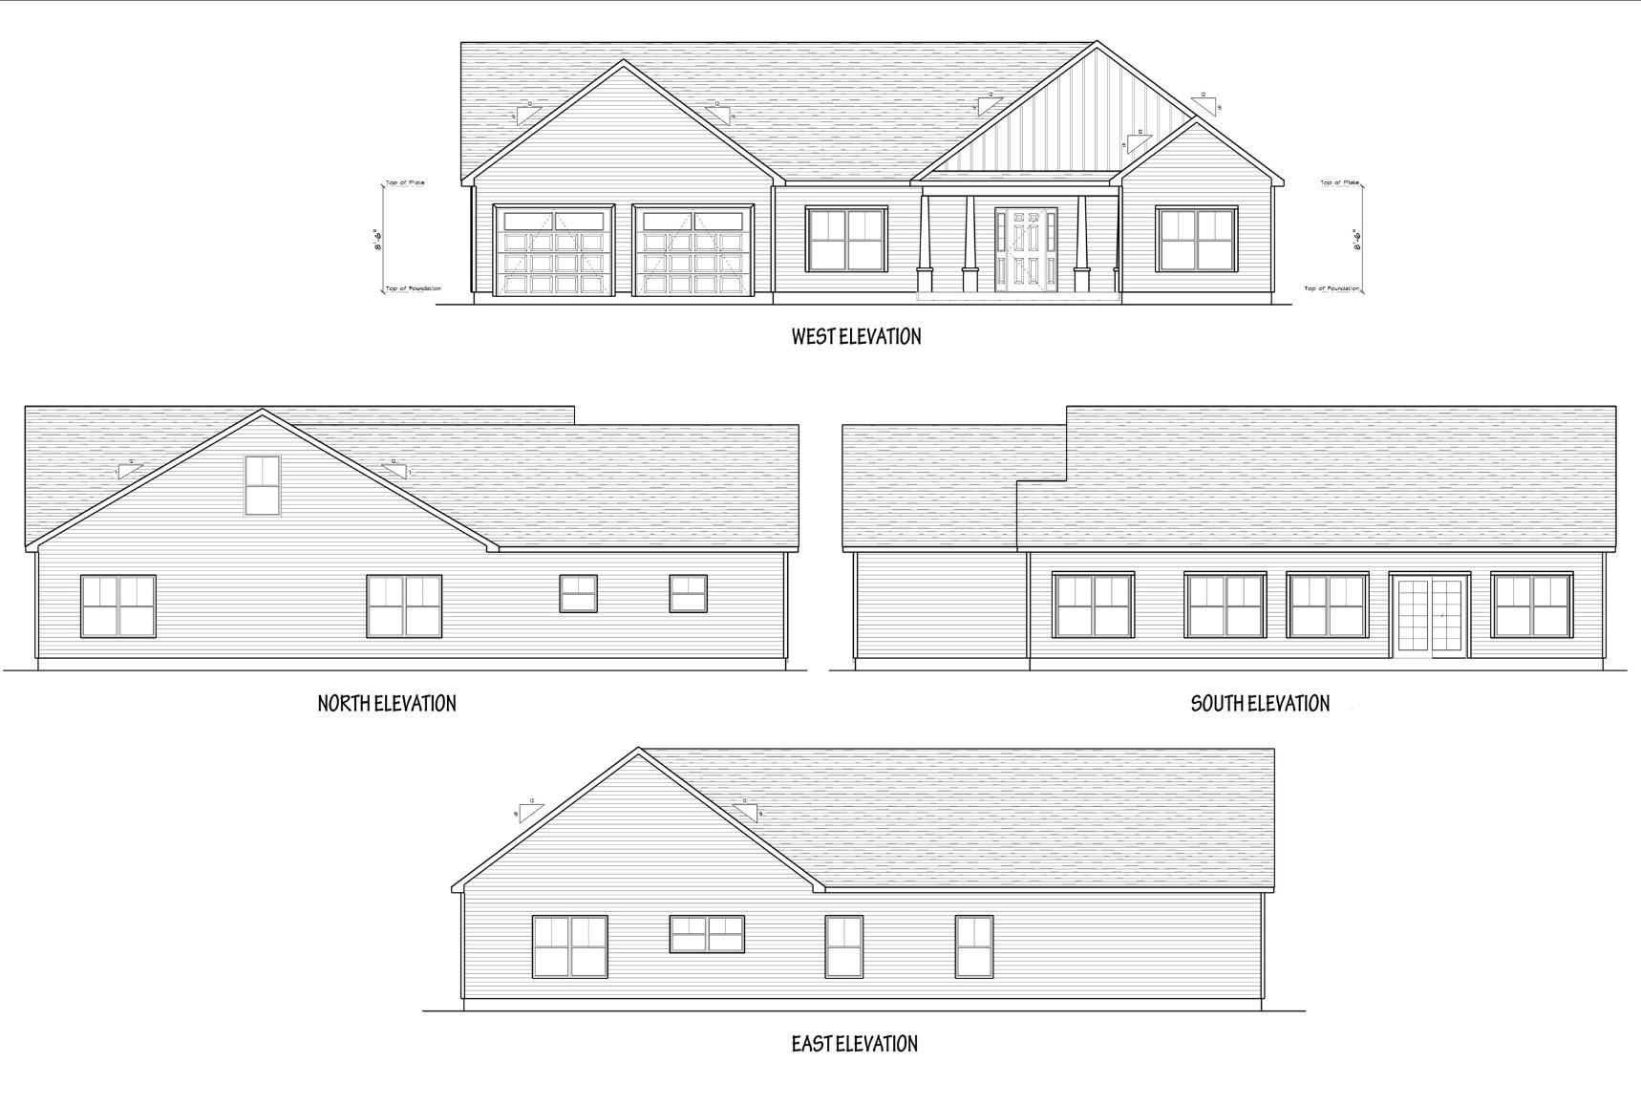
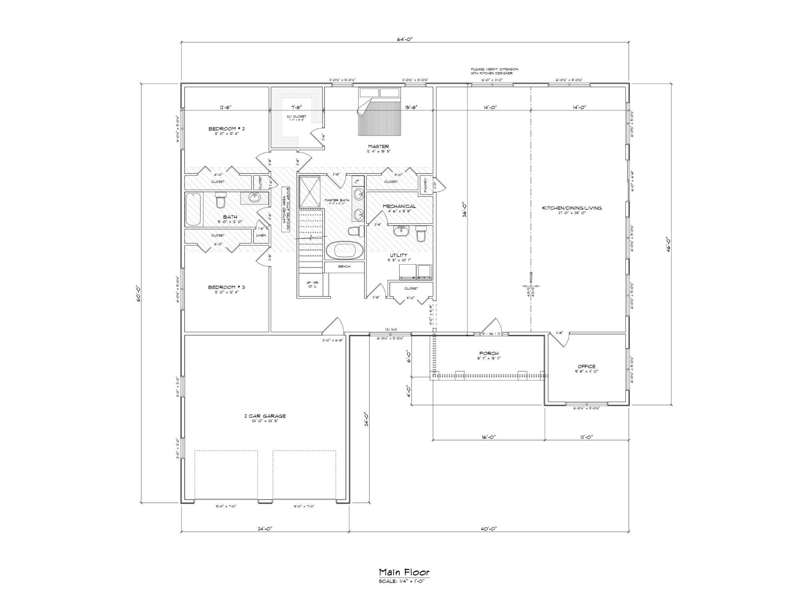

Section 2: Weatherization
Please provide detailed cost proposals for weatherizing the two homes described in the scenarios below. In addition, please submit further information on hourly rates, mark-up on materials, and per item pricing in sections below.

Scenario 1
Please provide detailed information and costs for a home weatherization project matching the specifications below:
Site and system specifications
- 1970’s ranch home with attached garage
- 24’x40’
- 2x4 walls with fiberglass insulation
- R-19 batts in attic
- Vinyl siding.
- Basement is uninsulated poured concrete.
- 1650 CFM50
Example photograph below:
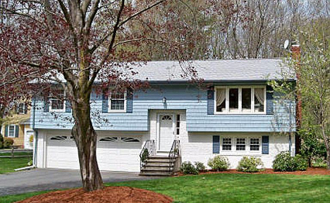

Scenario 2
Please provide detailed information and costs for a home weatherization project matching the specifications below:
Site and system specifications
- 100 year-old two story farm house
- Wood clapboard siding
- 2,300 square feet
- 2x4 walls, empty
- Attic has R-11 batts on top of 3” blown rock wool
- 3600 CFM50
- Basement is dry-laid fieldstone, dirt floor
Example photograph below:
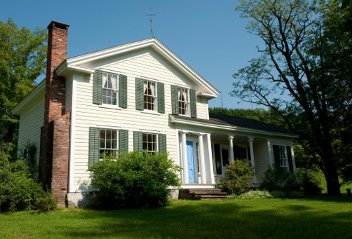

Please list your company’s hourly labor rates:
Please list your company’s mark-up on materials:
Per Item Pricing
In addition to the scenario pricing above, please provide further details on the per unit pricing for the various weatherization components. Please indicate both base rate for a minimum quantity and any additional rates that may change with increased quantity (e.g. Open attic insulation 6” depth is $X per square foot for the first XX square feet and $X per square foot for any additional square feet after the first 500).
Major Component |  | Base rate | Adder | Comments
Air sealing and ventilation options
Air Sealing |  | $ per hour | $ per hour
Door Weather-stripping and Sweep |  | $ per door | $ per door
Attic ventilation systems
 | Ridge vent | $ per linear foot | $ per linear foot
 | Soffit vent | $ per vent | $ per vent
 | Gable vent | $ per vent | $ per vent
 | Roof vent | $ per vent | $ per vent
Bathroom vents
 | Less than 4 feet to outside | $ per vent | $ per vent
 | More than 4 feet to outside | $ per vent | $ per vent
Insulation options
Sidewall insulation
 | 4” dense pack cellulose | $ per square ft | $ per square ft
 | 6” dense pack cellulose | $ per square ft | $ per square ft
 | 4” spray foam | $ per square ft | $ per square ft
 | 6” spray foam | $ per square ft | $ per square ft
Attic insulation (open)
 | 6” settled depth cellulose | $ per square ft | $ per square ft
 | 8” settled depth cellulose | $ per square ft | $ per square ft
 | 10” settled depth cellulose | $ per square ft | $ per square ft
 | 12” settled depth cellulose | $ per square ft | $ per square ft
 | 14” settled depth cellulose | $ per square ft | $ per square ft
Attic Insulation (floored)
 | 4” packed cellulose | $ per square foot | $ per square foot
 | 6” packed cellulose | $ per square foot | $ per square foot
 | 8” packed cellulose | $ per square foot | $ per square foot
 | Knee Wall (netted cellulose) | $ per square foot | $ per square foot
Attic Insulation (slope)
 | 4” cavity | $ per square foot | $ per square foot
 | 6” cavity | $ per square foot | $ per square foot
Rim Joist Insulation (with thermal barrier/fire protection)
 | 2” foam | $ per square foot | $ per square foot
 | 3” foam | $ per square foot | $ per square foot
 | 4” foam | $ per square foot | $ per square foot
 | 5” foam | $ per square foot | $ per square foot
Other Foam Insulation (provide R-value)
 | 2” foam | $ per square foot | $ per square foot
 | 3” foam | $ per square foot | $ per square foot
 | 4” foam | $ per square foot | $ per square foot
Existing Hot water tanks Insulation |  | $ per unit | $ per unit
Existing Hot water pipe insulation |  | $ per linear foot | $ per linear foot

Section 3: Heat Pump Water Heaters
Please provide customer proposals for the installation of 50-gallon and 80-gallon heat pump water heaters matching the specifications below. The proposal should be presented in your company’s proposed standard format for the EnergySmart Homes Westchester Program. Descriptions of cost adders, additional options, or any additional information may be provided in a separate addendum.
Site and system specifications
- Home has suitable clearance and an existing condensate drain that can be tied into.
- Quoted installed cost should include cost of removal and disposal of existing water heater from basement or similar space.
- Quoted installed cost should include cost of standard pipes, valves, and fittings and reconnection to existing cold and hot water lines (assuming no replacement of shutoff valves)
- Quoted installed cost should include expected costs for permitting and inspection
- System must be at minimum ENERGY STAR-certified, capable of being installed in conditioned, semi-conditioned, and unconditioned spaces. Sustainable Westchester has a preference for systems that meet Tier 3 of NEEA’s Advanced Water Heater Specification Qualified Products List (https://neea.org/img/documents/qualified-products-list.pdf).

Your proposal must include the following information:
- System Make, Model, and UEF: You may propose more than one model for each system size
- Installed Cost
- Manufacturer Warranty
- Labor Warranty
- Annual Service Plan (if available): Please describe cost and services included
- Any Common Cost Adders (e.g. electrical upgrade, condensate pump, main water shutoff valves)

Section 4: Ground Source Heat Pumps
All pricing should include complete installation under standard conditions. Assume that no special upgrades are required and no unusual challenges exist to complicate installation. Tonnage criteria refer to the design temperature (0F) heating demand of the hypothetical homes, not any aspect of nominal size. Please include the incentive rates for 2025. Actual prices may also vary for specific jobs based on the number of special circumstances and associated additional costs, which should be listed on contracts
This chart gives examples of installed costs for GSHP systems for standardized heating demands and no extra features. Actual costs will vary with other system sizes, complexity, special challenges and upgrades. The prices given represent the cost of the system before any incentives.
 | Forced Air Delivery Systems |  | Hydronic Delivery Systems
 | 2 ton forced air | 4 ton forced air | 2 ton hydronic | 4 ton hydronic
Make & model#
Manufacturer’s Parts warranty, yr
Manufacturer’s Labor warranty, yr
Baseline (horizontal loop field) Installed cost, $
Additional charge, for a vertical loop field? $/system
Inclusion of DHW, $ installed cost
Maintenance service and repair available, (Y/N)
Optional service contract available, (Y/N)
Annual cost of service contract for this system, $
Emergency Service available 7 days/wk, (Y/N)
Guaranteed emergency response time, Days
Service coverage at cost listed above:
Other comments:

APPENDIX 1
To be alerted to the posting of RFP-related questions and answers, register here to receive updates after May 30, 2025.

